Rfactor 2 supports the VNM Direct Drive Firmware controller device out-of-the-box.Configuration is straight-forward and can be done in game in the Setting menu

* Step 1: Go to Calibrate Control and choose to *Run Control Wizard* and follow the game instruction to bind and calibrate your devices. If the game doesn’t register your input, try to close and open the game again.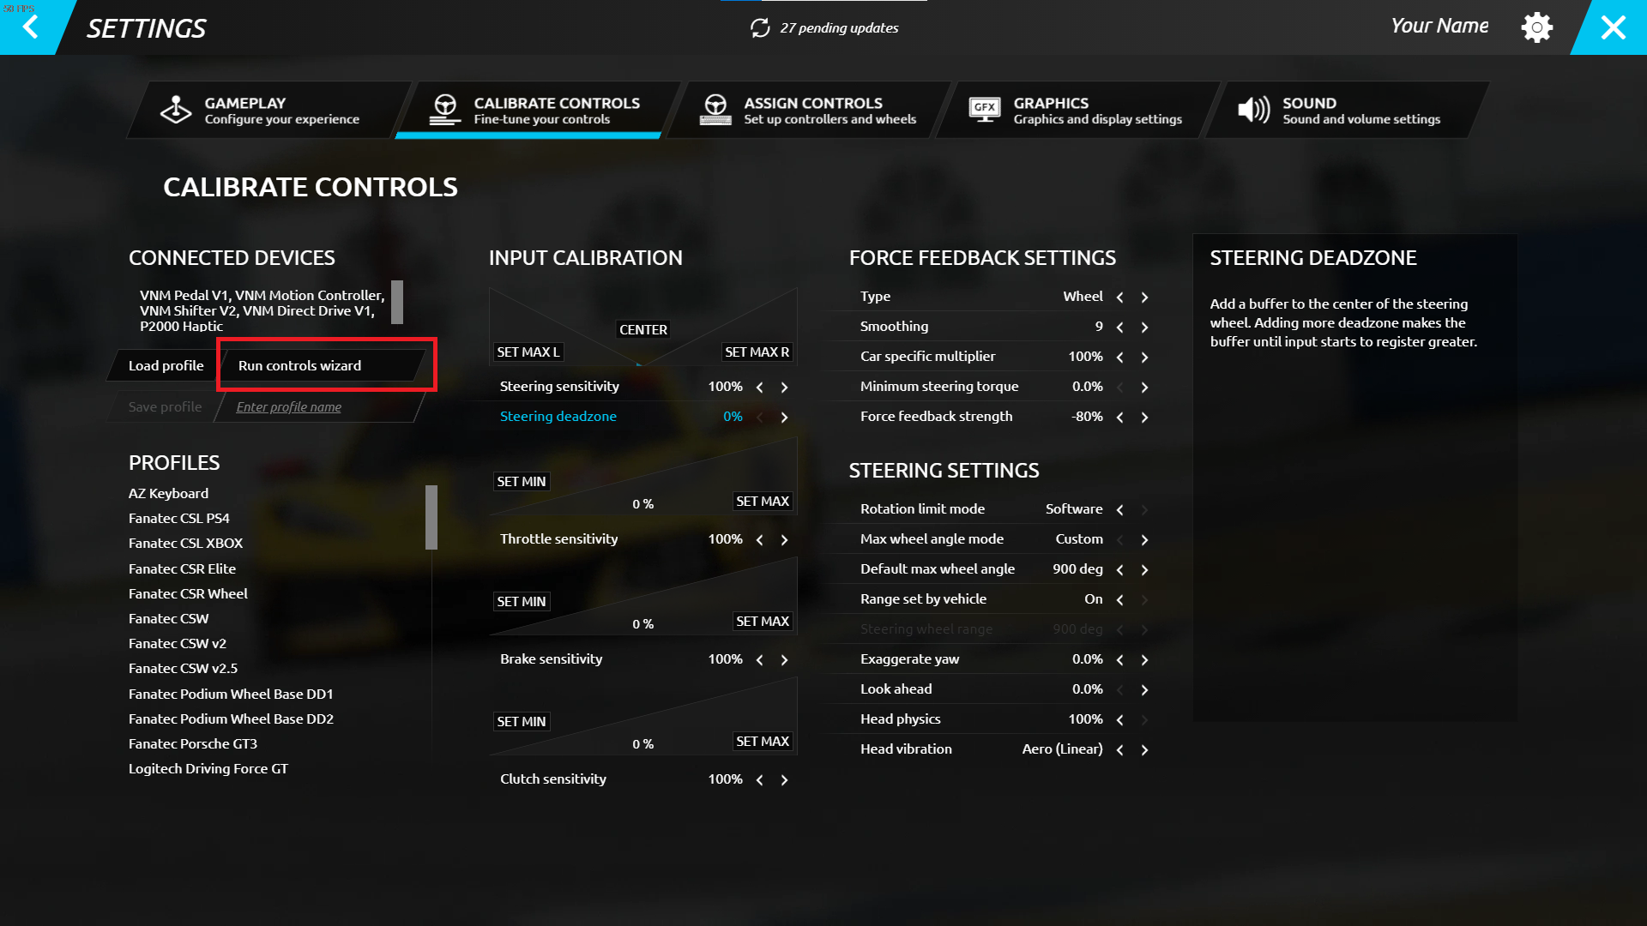

-Step 2: Set the FFB Strength to a negative value. The game register the FFB as inverted for some reason so if you left it at positive value and enter a race, the wheel will be lock to 1 side